ReplicaSet - Elections

- Login into primary [tom@localhost ~]$ mongo --port 27017


MongoDB shell version: 2.6.3
connecting to: 127.0.0.1:27017/test
myreplicaset:PRIMARY>

- Store configuration to a variable “config”

myreplicaset:PRIMARY> config=rs.conf();

{

"_id" : "myreplicaset",

"version" : 3,

"members" : [

{

"_id" : 0,

"host" : "localhost.localdomain:27017"

},

{

"_id" : 1,

"host" : "localhost.localdomain:27018"

},

{

"_id" : 2,

"host" : "localhost.localdomain:27019"

}

]

}

MongoDB Hands-on Page 1

ReplicaSet - Elections

- Update priority of members myreplicaset:PRIMARY> config.members[0].priority=3

3

myreplicaset:PRIMARY> config.members[1].priority=1 1

myreplicaset:PRIMARY> config.members[2].priority=2 2

- Reconfigure ReplicaSet with new configurations myreplicaset:PRIMARY> rs.reconfig(config)



2014-07-08T15:08:24.009+0200 DBClientCursor::init call() failed

2014-07-08T15:08:24.012+0200 trying reconnect to 127.0.0.1:27017

(127.0.0.1) failed

2014-07-08T15:08:24.013+0200 reconnect 127.0.0.1:27017 (127.0.0.1) ok reconnected to server after rs command (which is normal)

MongoDB Hands-on Page 2

ReplicaSet - Elections

- View ReplicaSet configuration myreplicaset:PRIMARY> rs.conf();


{
"_id" : "myreplicaset",
"version" : 4,
"members" : [
{
"_id" : 0,
"host" : "localhost.localdomain:27017",
"priority" : 3

},
{
"_id" : 1,
"host" : "localhost.localdomain:27018"
},
{
"_id" : 2,
"host" : "localhost.localdomain:27019",
"priority" : 2
}
]
}

MongoDB Hands-on Page 3

ReplicaSet - Elections

- Check status of the ReplicaSet myreplicaset:PRIMARY> rs.status();


{
"set" : "myreplicaset",
"date" : ISODate("2014-07-08T13:09:19Z"),
"myState" : 1,
"members" : [
{
"_id" : 0,
"name" : "localhost.localdomain:27017",
"health" : 1,
"state" : 1,

"stateStr" : "PRIMARY",
"uptime" : 1134,
"optime" : Timestamp(1404824903, 1),
"optimeDate" : ISODate("2014-07-08T13:08:23Z"),
"electionTime" : Timestamp(1404824025, 1),
"electionDate" : ISODate("2014-07-08T12:53:45Z"),
"self" : true
},
{
"_id" : 1,
"name" : "localhost.localdomain:27018",
"health" : 1,
"state" : 2,
"stateStr" : "SECONDARY",
"uptime" : 56,
"optime" : Timestamp(1404824903, 1),
"optimeDate" : ISODate("2014-07-08T13:08:23Z"),
"lastHeartbeat" : ISODate("2014-07-08T13:09:17Z"),
"lastHeartbeatRecv" : ISODate("2014-07-08T13:09:18Z"),
"pingMs" : 0,
"lastHeartbeatMessage" : "syncing to:
localhost.localdomain:27017",
"syncingTo" : "localhost.localdomain:27017"
},
{
"_id" : 2,
"name" : "localhost.localdomain:27019",
"health" : 1,
"state" : 2,
"stateStr" : "SECONDARY",
"uptime" : 56,
"optime" : Timestamp(1404824903, 1),
"optimeDate" : ISODate("2014-07-08T13:08:23Z"),

"lastHeartbeat" : ISODate("2014-07-08T13:09:17Z"),
"lastHeartbeatRecv" : ISODate("2014-07-08T13:09:19Z"),
"pingMs" : 0,
"lastHeartbeatMessage" : "syncing to:
localhost.localdomain:27017",
"syncingTo" : "localhost.localdomain:27017"
}
],
"ok" : 1
}

MongoDB Hands-on Page 4

ReplicaSet - Elections

7. Exit from the primary

myreplicaset:PRIMARY> exit
bye

8. Stop the current master process

[tom@localhost ~]$ sudo su [sudo] password for tom: [root@localhost tom]# cd /var/lib/mongo [root@localhost mongo]# ps -ef|grep mongo

root | 2984 | 1 | 0 | 14:50 ? | 00:00:03 mongod --port 27017 -
dbpath /var/lib/mongo/replicaset0 --logpath
/var/lib/mongo/replicaset0/log --replSet myreplicaset --fork --
smallfiles --nojournal
root | 3036 | 1 | 0 | 14:51 ? | 00:00:02 mongod --port 27018 -
dbpath /var/lib/mongo/replicaset1 --logpath
/var/lib/mongo/replicaset1/log --replSet myreplicaset --fork --
smallfiles --nojournal
root | 3082 | 1 | 0 | 14:51 ? | 00:00:02 mongod --port 27019 -

dbpath /var/lib/mongo/replicaset2 --logpath /var/lib/mongo/replicaset2/log --replSet myreplicaset --fork -- smallfiles --nojournal

 | root | 3699 | 3682 0 | 15:11 pts/2 | 00:00:00 grep mongo
[root@localhost |  |  | mongo]# | kill -9 2984

9. Login into mongo with priority 2

[root@localhost mongo]# mongo --port 27019

MongoDB shell version: 2.6.3

connecting to: 127.0.0.1:27019/test

myreplicaset:PRIMARY>

MongoDB Hands-on Page 5

ReplicaSet - Elections

- Check configuration myreplicaset:PRIMARY> rs.conf();


{
"_id" : "myreplicaset",
"version" : 4,
"members" : [
{
"_id" : 0,
"host" : "localhost.localdomain:27017",
"priority" : 3

},
{
"_id" : 1,
"host" : "localhost.localdomain:27018"
},
{
"_id" : 2,
"host" : "localhost.localdomain:27019",
"priority" : 2
}
]
}

MongoDB Hands-on Page 6

ReplicaSet - Elections

- Check ReplicaSet status myreplicaset:PRIMARY> rs.status();


{
"set" : "myreplicaset",
"date" : ISODate("2014-07-08T13:13:37Z"),
"myState" : 1,
"members" : [
{
"_id" : 0,
"name" : "localhost.localdomain:27017",
"health" : 0,
"state" : 8,

"stateStr" : "(not reachable/healthy)",
"uptime" : 0,
"optime" : Timestamp(1404824903, 1),
"optimeDate" : ISODate("2014-07-08T13:08:23Z"),
"lastHeartbeat" : ISODate("2014-07-08T13:13:35Z"),
"lastHeartbeatRecv" : ISODate("2014-07-08T13:12:12Z"),
"pingMs" : 0
},
{
"_id" : 1,
"name" : "localhost.localdomain:27018",
"health" : 1,
"state" : 2,
"stateStr" : "SECONDARY",
"uptime" : 312,
"optime" : Timestamp(1404824903, 1),
"optimeDate" : ISODate("2014-07-08T13:08:23Z"),
"lastHeartbeat" : ISODate("2014-07-08T13:13:35Z"),
"lastHeartbeatRecv" : ISODate("2014-07-08T13:13:36Z"),
"pingMs" : 0,
"lastHeartbeatMessage" : "syncing to:
localhost.localdomain:27019",
"syncingTo" : "localhost.localdomain:27019"
},
{
"_id" : 2,
"name" : "localhost.localdomain:27019",
"health" : 1,
"state" : 1,
"stateStr" : "PRIMARY",
"uptime" : 1325,
"optime" : Timestamp(1404824903, 1),
"optimeDate" : ISODate("2014-07-08T13:08:23Z"),

"electionTime" : Timestamp(1404825141, 1),
"electionDate" : ISODate("2014-07-08T13:12:21Z"),
"self" : true
}
],
"ok" : 1
}

MongoDB Hands-on Page 7

ReplicaSet - Elections

- Exit from the current primary

myreplicaset:PRIMARY> exit
bye

- Restart the killed process [root@localhost mongo]# rm replicaset0/mongod.lock

rm: remove regular file `replicaset0/mongod.lock'? yes
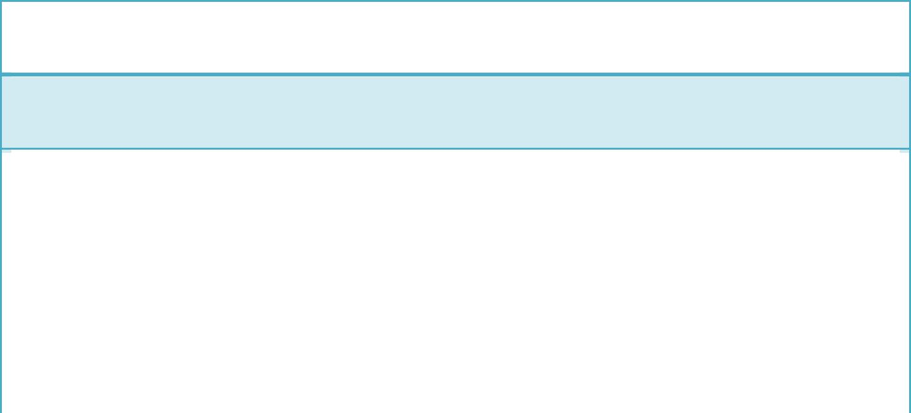

[root@localhost mongo]# mongod --port 27017 --dbpath /var/lib/mongo/replicaset0 --logpath /var/lib/mongo/replicaset0/log -- replSet myreplicaset --fork --smallfiles --nojournal

about to fork child process, waiting until server is ready for connections.

forked process: 5293

child process started successfully, parent exiting

- Login into the restarted process [root@localhost mongo]# mongo --port 27017
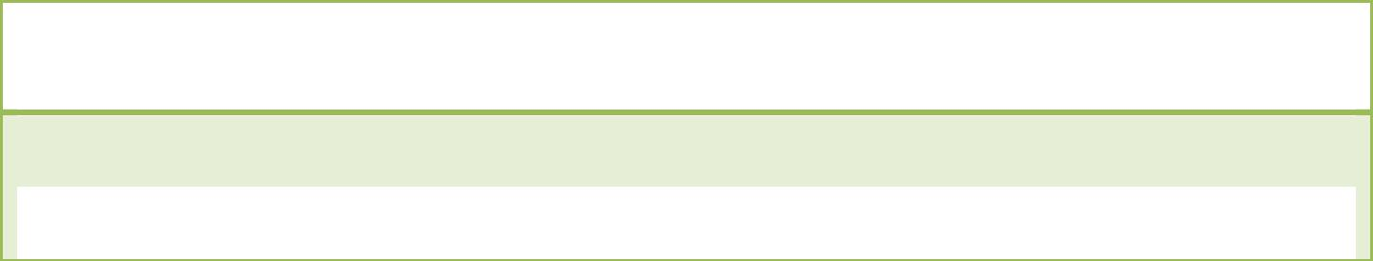

MongoDB shell version: 2.6.3

connecting to: 127.0.0.1:27017/test

MongoDB Hands-on Page 8

ReplicaSet - Elections

- Check ReplicaSet configuration myreplicaset:PRIMARY> rs.conf();

{
"_id" : "myreplicaset",
"version" : 4,
"members" : [
{
"_id" : 0,
"host" : "localhost.localdomain:27017",
"priority" : 3

},
{
"_id" : 1,
"host" : "localhost.localdomain:27018"
},
{
"_id" : 2,
"host" : "localhost.localdomain:27019",
"priority" : 2
}
]
}

MongoDB Hands-on Page 9

ReplicaSet - Elections

- Check ReplicaSet status myreplicaset:PRIMARY> rs.status();

{
"set" : "myreplicaset",
"date" : ISODate("2014-07-08T13:17:33Z"),
"myState" : 1,
"members" : [
{
"_id" : 0,
"name" : "localhost.localdomain:27017",
"health" : 1,
"state" : 1,

"stateStr" : "PRIMARY",
"uptime" : 39,
"optime" : Timestamp(1404824903, 1),
"optimeDate" : ISODate("2014-07-08T13:08:23Z"),
"electionTime" : Timestamp(1404825417, 1),
"electionDate" : ISODate("2014-07-08T13:16:57Z"),
"self" : true
},
{
"_id" : 1,
"name" : "localhost.localdomain:27018",
"health" : 1,
"state" : 2,
"stateStr" : "SECONDARY",
"uptime" : 38,
"optime" : Timestamp(1404824903, 1),
"optimeDate" : ISODate("2014-07-08T13:08:23Z"),
"lastHeartbeat" : ISODate("2014-07-08T13:17:33Z"),
"lastHeartbeatRecv" : ISODate("2014-07-08T13:17:33Z"),
"pingMs" : 0,
"lastHeartbeatMessage" : "syncing to:
localhost.localdomain:27019",
"syncingTo" : "localhost.localdomain:27019"
},
{
"_id" : 2,
"name" : "localhost.localdomain:27019",
"health" : 1,
"state" : 2,
"stateStr" : "SECONDARY",
"uptime" : 38,
"optime" : Timestamp(1404824903, 1),
"optimeDate" : ISODate("2014-07-08T13:08:23Z"),

"lastHeartbeat" : ISODate("2014-07-08T13:17:33Z"),
"lastHeartbeatRecv" : ISODate("2014-07-08T13:17:32Z"),
"pingMs" : 0,
"lastHeartbeatMessage" : "syncing to:
localhost.localdomain:27017",
"syncingTo" : "localhost.localdomain:27017"
}
],
"ok" : 1
}

MongoDB Hands-on Page 10

ReplicaSet - Elections

- Exit from the primary.

myreplicaset:PRIMARY> exit
bye

MongoDB Hands-on Page 11

